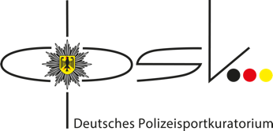

5th USPE European Police Championship
Volleyball Women

8th – 15th September 2024 in Saarbrücken/Germany
Form 1 – Registration of participation
Please send the Form until 12th March 2023
Country:

We let you know that we |  | participate
 |  | do not participate

It is necessary to inform about non-participation.

Person in charge:

German Police Sports Board
E-mail: info@dpsk.de

Organsier
E-mail: LPP-EPM2024@polizei.slpol.de

USPE Technical Delegate
E-mail: dirk.weninger@polizei.berlin.de
E-mail: dirk.weninger@uspe.org

Office of the USPE Secretary General
E-mail: office@uspe.org
Union Sportive des Polices d‘Europe
Friedenssiedlung 6
98617 Meiningen
Germany
Fax: +49 3693 850 399

