Meiningen, 20th December 2022

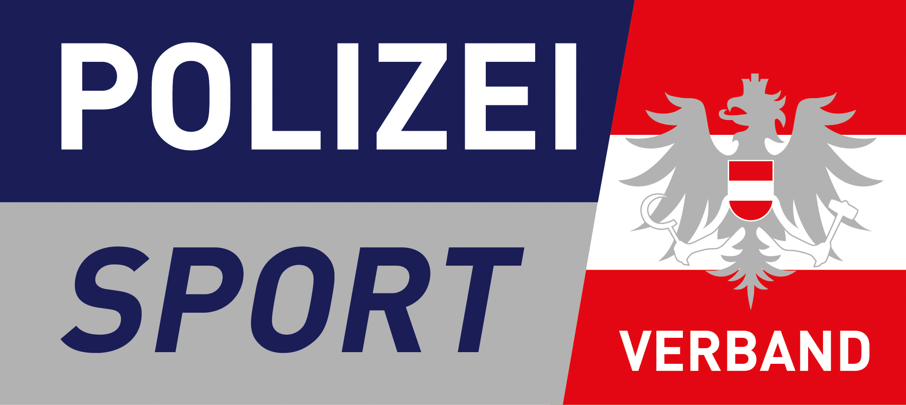

15th USPE European Police Championships
Alpine Skiing
6th – 10th March 2023 in Hinterstoder/Austria
Form 3 – Names of the Participants and Disciplines
Please send the Form until 9th February 2023
Country:

 | First name | Last name
Delegate
Attendant
Attendant
Attendant
Attendant
Guest(s)

Name:

Male athletes

No. | First name | Last name | Competition No.
 |  |  | 1 | 2 | 3
1
2
3
4
5
6
7
8
9
10
11
12

Competition No.:
1 | Giant Slalom (up to 3)
2 | Special Slalom (up to 3)
3 | Parallel Event (up to 3)

Female athletes

No. | First name | Last name | Competition No.
 |  |  | 1 | 2 | 3
1
2
3
4
5
6
7
8
9
10
11
12

Competition No.:
1 | Giant Slalom (up to 3)
2 | Special Slalom (up to 3)
3 | Parallel Slalom (up to 3)

Österreichischer Polizeisportverband
E-mail: OC-Austria2023@gmx.at
j.hirschberger@gmx.at

USPE Technical Delegate
E-mail: tamara.bollwein@polizei.gv.at

Office of the USPE Secretary General
E-mail: office@uspe.org
Union Sportive des Polices d‘Europe
Office of the Secretary General
Friedenssiedlung 6
98617 Meiningen
Germany
Fax: +493693 850399

Data protection notice:
The USPE member countries are responsible for the data protection of the data of their participants. Sending this form by unencrypted e-mail is not a secure way of transmission. It is recommended to send the form by post, fax or encrypted e-mail. Please note the data protection notices, the Declarations of Consent and the USPE Anti-Doping Declaration provided by the USPE in the Attachments 1 and 2 to Form 3.

