Meiningen, 20th December 2022
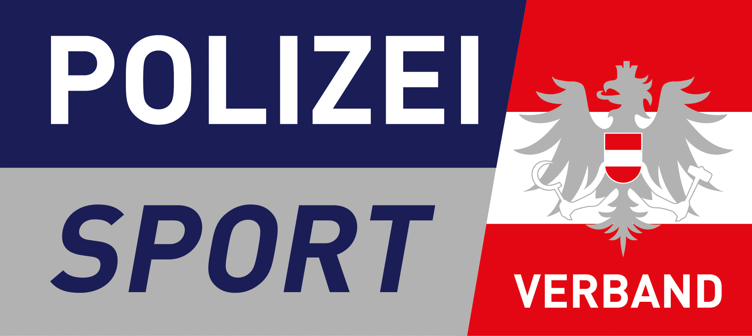

15th USPE European Police Championships
Alpine Skiing
6th – 10th March 2023 in Hinterstoder/Austria
Form 2 – Number of participants
Please send the Form until 27th December 2022
Country:

Delegate (1)
Attendant (up to 4)
Male Athletes (up to 12)
Female Athletes (up to 12)
Guest(s)

Name:

Österreichischer Polizeisportverband
E-mail: OC-Austria2023@gmx.at
j.hirschberger@gmx.at

USPE Technical Delegate
E-mail: tamara.bollwein@polizei.gv.at

Office of the USPE Secretary General
E-mail: office@uspe.org
Union Sportive des Polices d‘Europe
Office of the Secretary General
Friedenssiedlung 6
98617 Meiningen
Germany
Fax: +493693 850399

